目录

1 Write a Store Factory (no Proxy) 2

1coding 2

Step 1 start ganache 2

2 Manual test 3

2 make privateStamp factory upgradeable 4

2.1Verify old logic 4

2.2 Upgrade to v2 4

3 how to integrate ui to api 5

Step 1: go to ui and add proxy config to package.json 5

Step2: link node with react front end 5

Step 3, start nodejs 5

What is the different between ui integrates api and ui +api? 6

4 Webpack 6

4 Production: Dockernize the app 7

5 How to set domain for a website 7

# 1 Write a Store Factory (no Proxy)

Github.com/onebit256/proxy

## 1coding

## Step 1 start ganache

Ganache-cli -m ‘’

Truffle init

Npm init

Npm i @openzeppelin/upgrades@2.8.0

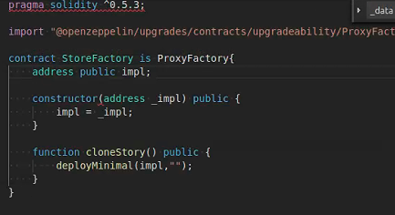

As there is no init function

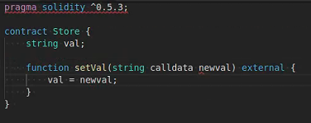

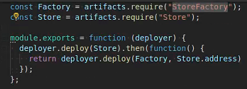

If there are init data

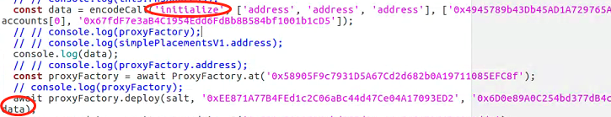

## 2 Manual test

Const sf = await StoreFactory.deployed()

Sf.impl()

Networks

Sf.clonestore()

Sf.getPastEvents()

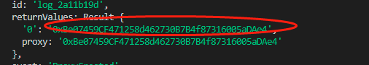

Const St1 = await Store.at(‘0xBe07459CF471258d462730B7B4f87316005aDAe4’)

St1.setVal(“ss”)

St1.val()

Sf.clonestore()

Sf.getPastEvents()

Const St2 = await Store.at(‘0xBe07459CF471258d462730B7B4f87316005aDAe4’)

St2.setVal(“ss”)

St2.val()

Sf.clonestore()

# 2 make privateStamp factory upgradeable

## 2.1Verify old logic

const proxyFactory =await ProxyFactory.at(ProxyFactory.address)

const proxyAdmin =await ProxyAdmin.at(ProxyAdmin.address)

const salt = "20";

const deploymentProxyAddress = await proxyFactory.getDeploymentAddress(salt, accounts[0]);

const implementationAddress = await proxyAdmin.getProxyImplementation(deploymentProxyAddress);

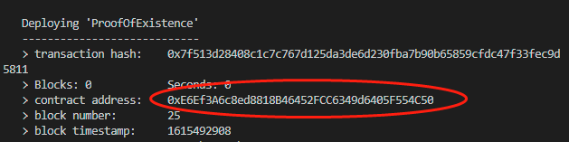



const poe1 =await ProofOfExistence.at(deploymentProxyAddress)

poe1.storeHash("123")

poe1.verifyHash(accounts[0],"123")



## 2.2 Upgrade to v2

await proxyAdmin.upgrade(deploymentProxyAddress, ProofOfExistenceV2.address)



const poe2 = await ProofOfExistenceV2.at(deploymentProxyAddress)



# 3 how to integrate ui to api

## Step 1: go to ui and add proxy config to package.json

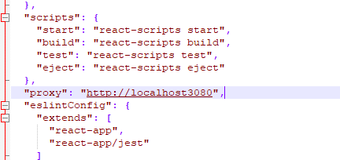

## Step2: link node with react front end

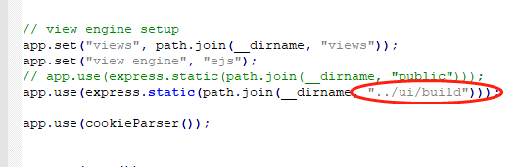

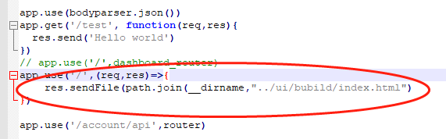

## Step 3, start nodejs

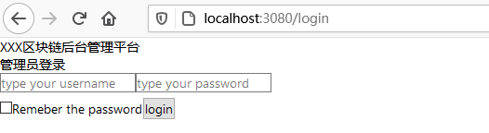

## What is the different between ui integrates api and ui +api?

# 4 Webpack

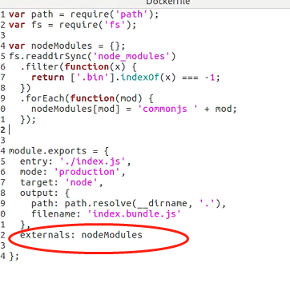

Exclude node_modules folder

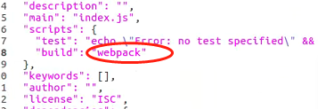

Add build script to package.json

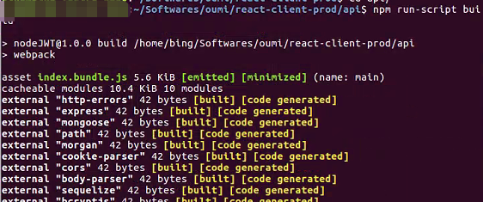

Npm run-script build

Then node index.bundle.js

# 5 pm2 host node application

npm install pm2 -g

Pm2 start index.js

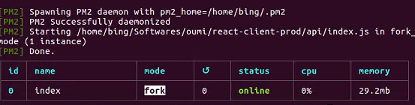

Pm2 stop 0

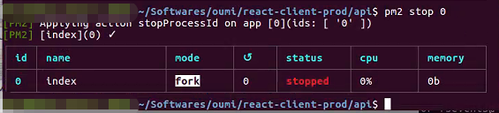

Pm2 list

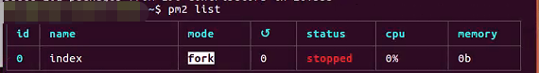

Pm2 logs 0

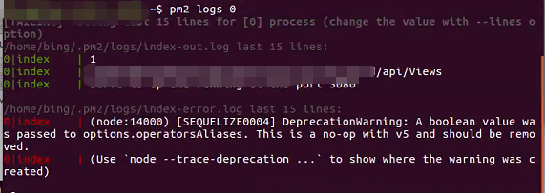

# 6 Production: Dockernize the app

Docker file

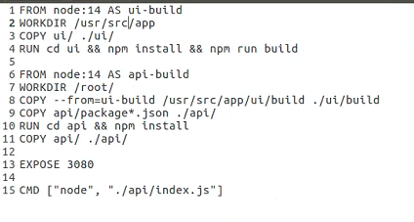

- copy --from-ui-build /usr/xxx ./ui/build

Copy directly from one image to another image

Docker compose

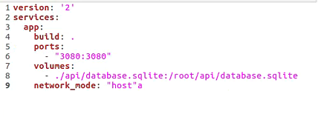

Note:

Map the database.sqlite to docker container

# 7 How to set domain for a website

After you buy a domain name from a dns provider, such as godaddy aws or google

1 go to your dns provider, in our case cloudflare, then click DNS

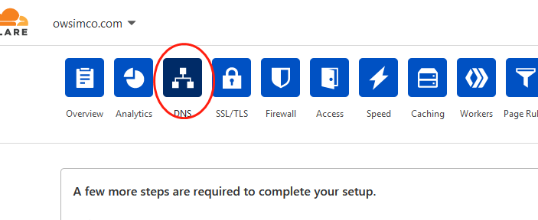

2 replace 127.0.0.1 with your read ip, and click save

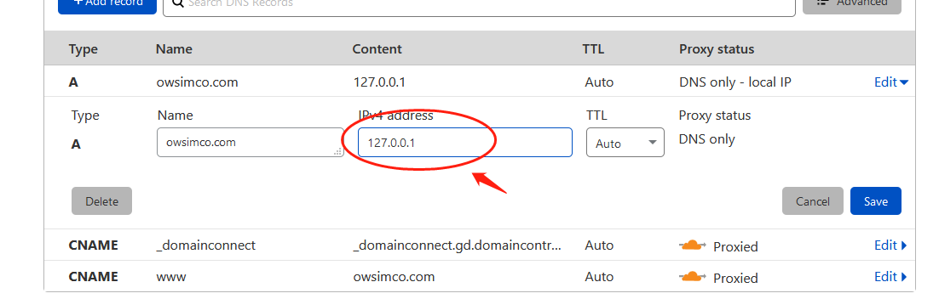

3 install nginx: sudo apt-get install nginx

4 go to /etc/nginx/sites-avaliable folder

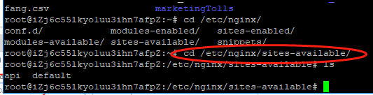

5 create ows.conf

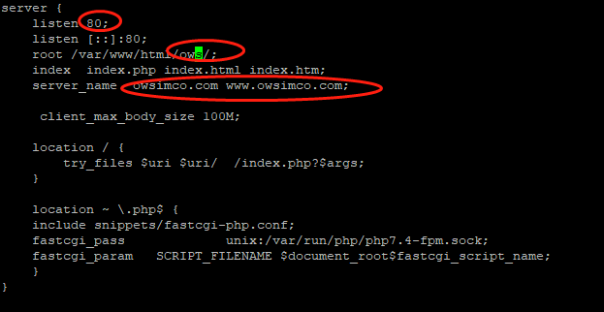

Put index.html to /var/www/html/ows

Set the domain name to server_name

6 ln -s /etc/nginx/sites-avaliable/ows.conf /etc/nginx/sites-enable/

7 create a hello world index.html in ows

8 change owner to www-data



9 type owsimco.com

